**Classroom Activity​: Write a function to check if a given number is an Armstrong number.​**

**​**

**Code-**

const num = 153; // You can change this value to test with different numbers

// Convert the number to a string to easily iterate over digits

const numStr = num.toString();

const numDigits = numStr.length;

let sum = 0;

// Iterate over each digit, convert to number, and compute the power sum

for (let digit of numStr) {

sum += Math.pow(parseInt(digit), numDigits);

}

// Check if the sum of powers equals the original number

const isArmstrongNumber = sum === num;

console.log(num + " is an Armstrong number: " + isArmstrongNumber);

**Output-**

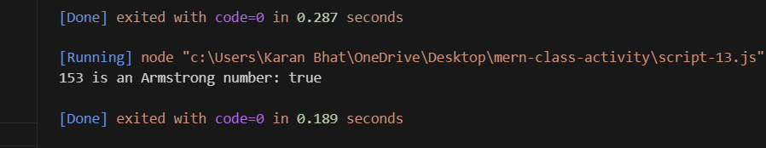

**Execution-Steps:**

* Create a JavaScript file with any name
* Write the code
* Run the code in the terminal using F5 or right click and go to inspect and you can get the output in the console as well.